Coreen John

FInal Project

v.5

**Table of Contents**

CHAPTER 1. Introduction 7

1.1. Overview of project concept 7

1.1.1. First component: 11

1.1.2. Second component: 11

1.2. Project Motivation 11

1.3. Background 11

1.4. Technical aims 13

1.5. Structure of Report 13

CHAPTER 2. Background research 13

2.1. Impact of an ageing population on society 13

2.2. Overview of patient discharge from hospital 14

2.3. Consequences of not receiving help once discharged from hospital 14

2.4. Benefits of assistive technologies 16

2.5. Existing systems 17

2.6. Ethical implications 18

CHAPTER 3. Stakeholder requirements 18

3.1. Stakeholder Focus Group Questionnaire 18

3.2. Conceptual Prototype 19

CHAPTER 4. Business Model 19

4.1. Competition? 19

4.2. Business Model Canvas 19

4.3. SWOT Analysis 19

4.4. [Revenue Model] 19

CHAPTER 5. Design Specifications 20

5.1. System Requirements 20

5.2. Risk Analysis 20

CHAPTER 6. System Design 20

6.1. Design methodology 21

6.2. Aim of the System 21

6.3. System Design 21

6.4. NP Application 21

6.5. Components of Wearable Device 22

6.6. Specification of system 22

6.7. Architecture of system 22

6.8. Design of User Interface for Wearable Device 22

6.9. Functional 22

6.10. Non-functional 22

6.11. Software and Hardware Platforms 22

CHAPTER 7. Design Elements 23

7.1. Use Case 23

7.2. Wireframes 25

7.3. Branding 29

7.4. User Interface 29

[Do some mock ups of user interface and explain] 29

7.5. [System interactions] 29

7.6. Prototyping 29

CHAPTER 8. System Architecture 29

8.1. Functionality of system 29

8.2. Systems architecture 29

8.3. Technical reports 29

8.4. Components 29

CHAPTER 9. Implementation 29

9.1. Wearable Device 29

9.2. App 29

9.3. MVP 29

9.4. Stage 1 29

9.5. Stage 2 30

9.6. Stage 3 30

CHAPTER 10. Testing 30

10.1. Overview of testing methods 30

10.2. Black box 30

10.3. White box 30

10.4. User testing 30

CHAPTER 11. Successes and Issues 30

11.1. Technical successes 30

11.2. Evaluation of system 30

11.3. User experience 30

CHAPTER 12. Conclusion 30

2. Bibliography 32

3. Appendices 33

Appendix A. [Orientation Model] 34

Appendix B. Stakeholder Focus Group Questionnaire 35

Appendix C. Conceptual Prototype Walkthrough for Stakeholder Focus Group Session 38

**List of Tables**

Table 1: Description of Assistive technologies used by elderly people (GeorgiaTech, 2019) 16

**List of Figures**

Figure 1: Percentage of population age 65 and over in 1997 7

Figure 2: Percentage of population age 65 and over in 2017 8

Figure 3: Percentage of population age 65 and over in 2027 8

Figure 4: Percentage of population age 65 and over in 2037 9

Figure 5: Morality rates 1965-2020 10

Figure 6: Percentage of people expected to survive to age 100: 1981-2066 10

Figure 7: Landing page and login page 25

Figure 8: New user login and registration form 26

Figure 9: Existing user login pages 27

Figure 10: User interaction screens 28

Figure 11: Step 1 - Home Screen 38

Figure 12:Step 2 - Voice Messaging Screen 39

Figure 13: Step 3 - Voice Message confirmation screen 40

Figure 14: Step 4 - Nominated Person message notification on the HomeHelp App 41

Figure 15: Step 5 - Back to Home Screen 42

Figure 16: Step 6 - SOS Activation Button screen 43

Figure 17: Step 7 - Nominated Person SOS Notification with GPS location map of user 44

Figure 18: Step 8 - Alternative designs 45

**Abstract**

The aim of the proposal is to address the lack of assistance patients receive when they are discharged from hospital. Currently there are some support mechanisms that are in place but because of financial restraints on social services, this assistance is limited or not offered. By creating a community of users through an electronic device, will give patients the capability of carrying out day to day activities post-discharge. The system will provide the user with a wearable device uses speech to transmit a message via SMS to a nominated person that has a compatible application. The device will also have the capability of sending SOS messages in the event of an emergency. [To be rewritten at the end]

1. Introduction

## Overview of project concept

We currently have the largest UK population recorded, estimated at 66 million in 2017. This growth trend is set to continue with the population predicted to reach almost 73 million by 2041. As the population grows, and life expectancy rates improve we will also be living in an ageing population. In mid-2017 those aged 65+ stood at 18.2% of the population, this will grow by 2.5% by 2027 (ONS, 2017) [with this age group outnumbering [insert age group from visualisation]. See Figure 1, Figure 2, Figure 3 and Figure 4 below.

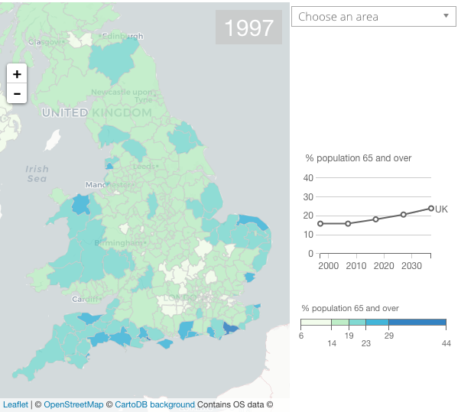

Figure 1: Percentage of population age 65 and over in 1997

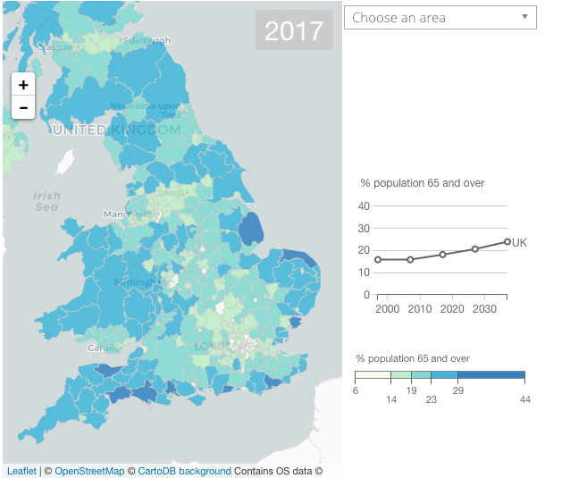

Figure 2: Percentage of population age 65 and over in 2017

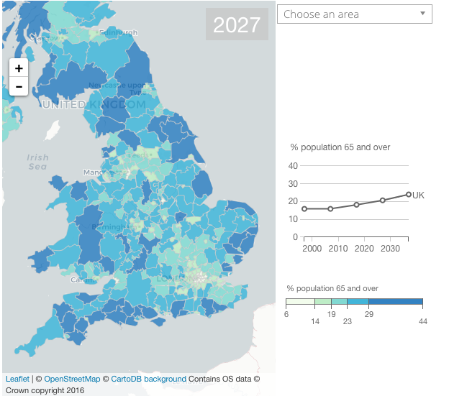

Figure 3: Percentage of population age 65 and over in 2027

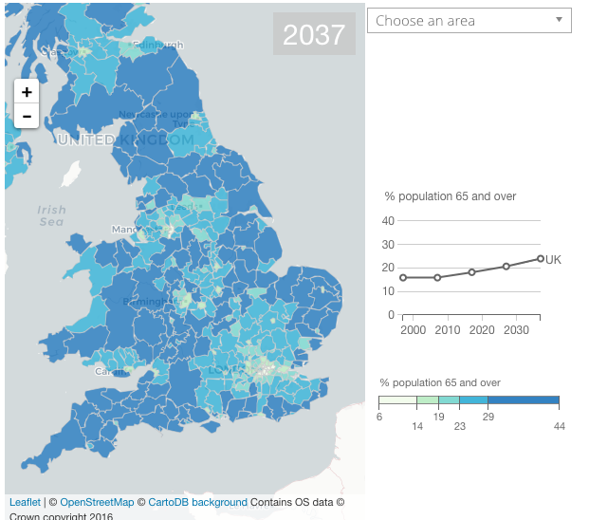

Figure 4: Percentage of population age 65 and over in 2037

[*insert own visualisation and expand*]

As we are heading towards living in an ageing population, mortality rates will be at an all-time low. If this trend keeps on this downward decline, (Figure 5 below) it 41% of males and 49% of females are set to survive to age 100 by 2066 (Figure 6 below). This is good news that the population is surviving for longer, it is indicative of healthier lifestyles and improved healthcare. There are many positive aspects to these findings; more volunteers, a population who are able to work and contribute to the economy for a longer period of time and people able to care for older family members. In contrast to this there are also many implications. As a person becomes older their quality of life and health will degenerate. There may be a number of factors that will contribute to this degeneration. For example, older people are more likely to live alone, many who are widowers may not remarry after a death of a partner, leading to isolation and loneliness. This in turn may lead to a demise in health which will have an impact on the economy, public services and health services; which all need to be taken into consideration. Moreover, if the population is living longer and working longer, informal carers, as a result, may not be able to care for ailing relatives, resulting in extra pressure on social services.

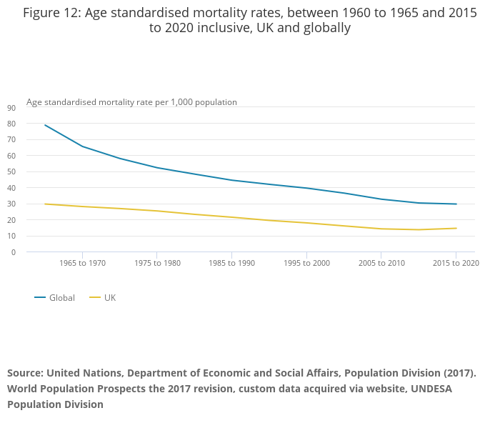

Figure 5: Morality rates 1965-2020

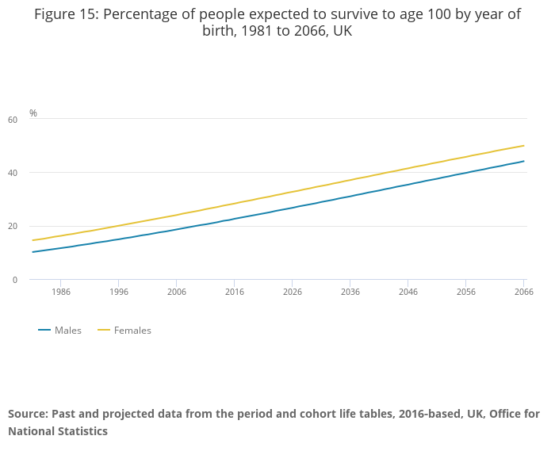

Figure 6: Percentage of people expected to survive to age 100: 1981-2066

The consequences of an ageing society can be described as:

* increased impact on social services as people live for longer;
* more resources will be needed for social services;
* increased isolation in older people;
* older people will find it more difficult to perform day to day activities; and
* more hospital admissions.

In order to address these issues, the aim of this project is to implement and design an assistive device that will allow elderly patients who have been discharged from hospital. The device will act as a communication tool, that will allow [patients] to seek assistance with daily activities when required. Alleviating the isolation that can be caused, when there are no formal discharge plans in place once released from hospital. The system will be split into two components:

## First component:

A wearable device which will enable the user to request help by way of speech; for example:

* + - “*need bread and milk*”; or
    - “*need a letter posting*”; or
    - “*need to visit the bank*”; and
    - a facility to communicate an SOS alarm, in the case of an emergency.

## Second component:

Will be in the form of a mobile application which will be used by the nominated participants to receive the messages that are sent by the primary user.

The device is not limited to this particular group of people and could also be used by can groups that are housebound, young carers or as a general safety alarm to ensure a sense of community and safety amongst users.

*Any known systems currently in use? - Insert from page 7: 2.3 of the proposal*

*How will the system be accessed?] - Write a brief synopsis of how the system will be accessed.*

## Project Motivation

*Mention any particular system that it will use and why.*

*Mention any key motivating factors i.e. the lack of support that is given to patients when they are discharged from hospital.* ]

Many of the assistive devices that are in existence are often limited to those who reside in Retirement Housing where they have an integrated alarm system that makes use of telecare assistance that offers residents 24 hour care all year round (Hanover, 2019). This system is limited to those who reside in these types of establishments, elderly people who live independently in their own home, are limited to this type of care as it would be costly (£63 a month for a similar service (Telecare Choice, 2019) for this type of system to be implemented in a private home.

## Background

Healthcare spending has dropped since 2010 to £700 million. In 2011 800,000 older people whose care needs were not met with a drop in the number of social workers that will not be able to meet the needs of the ageing population which will see a rise in the population looking for alternative forms of assistance within their homes (Caleb-Solly, 2016).

[*What are the effects of lack of contact, loneliness, recurrence of illness, readmission to hospital?]*

What are the current devices that are aiming to address these issues? - Look at page 7 - 2.3]

Make a list of all assistive technologies that are currently used by elderly people. [*Look at research documents*]

[Insert visualisation]

The emergence of smartwatches is still in its infancy and the outlook for these devices are very positive. The capabilities are [endless] from monitoring everyday health through to ensuring vulnerable people are supported in various [scenarios] (Reeder and David, 2016). There are currently existing systems in the that are available on the market that aim to satisfy the need for assistive technologies which will be discussed in turn.

Omate Wherecome S3 (2016) is a smartwatch which has been manufactured by Omate which is designed for the elderly population for monitoring of elderly or vulnerable members of a family. A standalone device that runs on Android platform. The device has an integrated alarm that can remind the user when to take their medication and also has a built in pedometer. There are a few capabilities of the device such as a dialler, message hub and an SOS button. When activated the SOS signal, will send the location of the user via GPS to their nominated contacts over WI-FI or 3G. The device does not have the capability of speech recognition or transmission.

The Tempo (2019) A wearable device that has a sensor that can help health workers identify serious health concerns in the elderly. Tempo learns the activity behaviour of the user. The device can also alert the carer if the user has eaten less that day. The data can be accessed with CarePredict software. This device is more of a health alert system and differs slightly from the proposed product, as it does not allow for message interchange with the user and the caregiver.

Revolutionary Tracker is a standalone smartwatch that is an integration of Samsung Gear S2 and S3. The smartwatch comprises a silicone band, square metallic case with GPS and SOS button. With a press of a button the wearer can be connected to a family member or caregiver. Real-time tracking is achieved through tablet or smartphone with a compatible app. Users can set safe zones so if the user goes beyond the zone an alarm will be raised.

[*Insert arguments against these*]

Although these products described above exist, it seems that availability is limited to overseas countries. There does not seem to be an assistive device on the market that addresses the needs of consumers in the UK and is incorporated into a discharge plan. There are safety alarms that are in existence in the UK, but they seem only be available to people that live in 55+ communities where assistive devices are integrated into self-contained flats. They do not take account of consumers that live independently that do not have access to this kind or system in their home and would come at a cost. By supplying this sort of device to patients on discharge will assist in allowing convalescing patients to continue living an independent life and giving them the best change of recuperation in the long term.]

## Technical aims

[*Say what the technical aims are: to assist in the rehabilitation and building of community with patients that are discharged from hospital by creating a system that offers real-time communication between [caregivers] and people in need (this assistance is not limited to patients that are discharged from hospital and can be utilised in many settings such as young carers, women travelling alone at night, children walking home from school.*]

## Structure of Report

[*So far the paper has discussed the background for the project, the motivation for the project and how it will address the technical aim. The remainder of this report will be outlined as follows:*

[*Part 2: Background research*. *The aim of the sections is designed to give context to the project and will demonstrate the difficulties patients face when they are released from hospital without a support network and discharge plan in place.*

*Part 3: Design. Will detail the specifications of the system, a risk analysis will be conducted*

1. Background research

The following chapter will provide an analysis of the background research that was conducted for this project. An overview of the impact an ageing population has on society; followed by the consequences of not receiving help once discharged from hospital; the benefits of assistive technology; an overview of existing systems and finally the ethical implications of assistive technology.

## Impact of an ageing population on society

A major impact of an ageing population will be: isolation. Many of the older population will become widowed or find themselves in a situation where they are living away from family members, meaning less support will be offered to this group. Loneliness is an issue within modern society and can present itself in many forms. It has been found that elderly or adolescents are prone to loneliness more than any other type of group (Kileen, 1997). As a result, there are various implications of loneliness. The emotional and psychological effects can be described as: low self-esteem, depression. The day to day effects can present itself in many forms such as: alienation, social isolation, estrangement, aloneness, solitude and a negative effect on a person's health (Kileen, 1997; Ivbijaro, 2013; Stojanovic et. al, 2016). As the population becomes larger, with people dying less, it is needless to say that this will have a significant impact on the level of service and economic impact on the National Health Service.

[Not sure if this is relevant]. Some forms of loneliness cannot be solved as it is embodied, if a person tries to combat this on behalf of somebody else it could make them revert deeper into their state In contrast, Kileen (1997) states that some patients that are admitted to hospital, view this as respite from their loneliness. With this said the direct effects of loneliness will result in some hospital patients, suffering loneliness, experiencing some sort of respite [from this] when they are admitted to hospital. This feeling could be eliminated if that person was a member of a community that were able to offer patients assistance. Not only on discharge from hospital but may also go some way to alleviate the direct effects of day to day loneliness. Moreover, this could also act as a preventative measure for hospital readmissions.

[*Not sure if this section should go here*]

## Overview of patient discharge from hospital

As highlighted in 2.1 above, there are many consequences as a result of an ageing population. [*Therefore*], there will be more hospital admissions as a result. One of the most important factors of patients having to stay in hospital will be there care that they receive by the NHS. Bruster et.al (1994) conducted an in-depth analysis of patient care within NHS hospitals. The analysis was borne from the requirement to review the NHS as there was a requirement for hospitals to assess the quality of care received by patients. The survey was designed to analyse 108 hospitals used in sample size and was conducted between 1992-1993. A random sample of 36 NHS hospitals with a sample group of 143 patients per hospital ranging from Medical and surgical wards. They conducted a series of interviews at home or place 2-4 weeks after discharge via a questionnaire. They asked participants about a series of questions based on:

* pre-admission procedures;
* admissions;
* communication with staff;
* physical care;
* tests and operations;
* help from staff;
* pain management; and
* discharge planning.

The report highlighted that discharge planning was a principal problem that had been reported by participants. One of the most prominent features, was the lack of communication management. Patients reported they were not given adequate information on how they should conduct their lives when they go home after discharge and were left with a feeling that they are not given enough information on their aftercare.

## Consequences of not receiving help once discharged from hospital

There are many repercussions to an unsuccessful discharge from hospital. One example given by an organisation, ‘Royal Voluntary Service’, who are a charity offering voluntary services by supporting NHS hospitals and wider communities. In their report ‘*Going Home Alone*’2013), they highlighted there has been a 10% population increase in those over 75 years old, with a 38% increase in hospital discharges for those over 75 years old. RVS (2013) reported 46% of those over 75 years old who had been in hospital, within the last five years were living alone, with 20% of hospital admissions being avoidable. There will be 40% more 65 to 84-year olds by early 2030s and more than twice as many people aged 85 or more. The report also highlighted there was very little support following discharge. With 15% of people said they felt anxious when leaving hospital, 41% felt they did not receive the support they needed and 30% of patients felt they needed just a little support were readmitted. RVS (2013) also reported a lack of support at home has a direct link to patients being readmitted to hospital (with 51% of patients being readmitted after discharge). They also concluded that the level and duration of support that is offered is insufficient. RVS (2013) suggests that the duration of support should be extended beyond the first six weeks of discharge from hospital (with 62% of patients reporting that they still needed assistance getting to the shop more than 6 weeks following discharge). (RVS, 2013) clearly highlights that there is a problem that is faced by patients when discharged from hospital.

Furthermore, demonstrating a lack of support for patients who are discharged from hospital, with the duration of support being limited. That is to say, that adequate discharge planning for hospital patients can be of immense benefit (Mamon et. al, 1992) demonstrating that some patients may be discharged with a higher level of dependency pre-admission. They surmise that a patient social mobility should be assessed before admission to determine whether they would need support on discharge, as 97% of patients needed some kind of aftercare and 11% had unmet activity limitation need. Therefore, highlighting again that patients being discharged from hospital, do not have sufficient care plans in place to ascertain whether they have sufficient support when being discharged. If they are offered support the duration of that support is very limited.

Healthwatch, an independent body, who monitor the use of health and social care services. A study conducted in 2015 analysed why discharges from hospital go wrong and the cost implications to the social health care system. They conducted research on people who were in the process of leaving hospital with input from their relatives and carers. Their research concluded that 1,000 of people are kept longer in hospital than is medically necessary because of administration delays. Coupled with the rising population of the elderly, healthcare costs going up along with poor patient experience found patients were not involved in decision-making of their discharge and were not given proper information. Many patients reported they were left without support after being discharged. A case study was analysed where a 75-year-old patient was due to be discharged from hospital. The patient was deaf, immobile and diabetic. It was discovered that the patient was discharged at the wrong time so there were no carers to receive her, she was dumped on a bed (the transporting staff accessed her key from a keysafe). A family member was unable to assist the patient immediately, so was left with no food and water for 2 hours. There is clear evidence that hospitals are implementing unsafe discharges: patients are being transferred before its clinically safe. They also concluded that there is no clarity on ongoing support availability when patients are discharged from hospital, clearly demonstrating that patients are being discharged before it has been ascertained whether they have sufficient support in place when they leave.

[*Not sure if this is relevant*]

[In this paper Barras et al. (2013) discuss the implications of discharging planning. The study was conducted in various countries such as US and UK were used in the case studies to ascertain how discharge procedures are conducted when a patient is admitted and released from hospital. A total of 11,964 participants were analysed in the study. There are discussions regarding discharge planning in hospitals. The study further discusses that some patients are discharged prematurely from hospital, resulting in unplanned readmission with a three-month period. It analysed that no sort of risk assessments is carried out before the patient is discharged. Therefore, no consideration is taken as to the patient’s social situation or if they have access to a support system on discharge. Barras et al, claim that those patients who had a care plan in place along with family input regarding their social situation, were less likely to be readmitted to hospital as their care needs were taken into consideration. Those patients whose social situation was not taken into consideration had a higher rate of readmission. Barras et al. did not conclude that discharge planning saves healthcare systems money.

This paper is relevant to the project as it highlights the psychological effects and social effects of patients on leaving hospital when there is not discharge plan in care. It highlights that if a patient has their social situation assessed it could prevent the rate of readmission to hospital, it also demonstrates that patients do need social support when leaving hospital to assist with day to day tasks]

## Benefits of assistive technologies

[*What are the benefits of assistive technologies and how have they benefited, look at the papers that have been reviewed.*]

There are many types of assistive technologies that are used by elderly people (see Table 1 below).

Table 1: Description of Assistive technologies used by elderly people (GeorgiaTech, 2019)

| Level of tech | Tech Type |
| --- | --- |
| Low | Handheld magnifiers |
|  | Large print text |
|  | Using paper and pen to communicate |
|  | Canes and walkers |
|  | Reachers / grabbers |
|  | Specialised pen or pencil grips |
| Middle | Talking spell checkers |
|  | Manual wheelchairs |
|  | Electronic organisers |
|  | Closed Caption Televisions (CCTV’s) |
|  | Amplifiers |
|  | Books on CD |
|  | Environmental Control Units (ECU) |
|  | Alternate mouse or keyboard for the computer |
| High | Power wheelchairs and scooters |
|  | Digital Hearing aids |
|  | Computers with specialised software such as voice recognition or magnification software |
|  | Electronic aids to daily living |
|  | Digital hands free headsets |
|  | Communication devices with voices |
|  | Bluetooth integration |
|  | Digi-drive technology (operating a vehicle with a joystick) |

## Existing systems

Long term care is normally provided through either self-care or aided by the use of assistive technology (Agree, 1998). Using assistive devices can result in elderly people with leading an independent lifestyle. This can lead to an improved quality of a person's health and lifestyle and reassurance to families who may care for those in an ageing population (Zwijsen et.al, 2011; Coleb-Solly, 2016). The use of assistive devices along with the incorporation of advancing technologies could make the process of support for the elderly more streamlined (Zwijsen et. al, 2011; Agree, 2014).

As the world is becoming more digitised this age group can be made to feel isolated as they are more resistant to using technology. On the other hand, the study also reported that internet use for 75 year age group has doubled between 2011-2017. But it is fair to say that older people may never catch up with technological advance and because of this older people feel more connected with their community (ONS, 2017).

Many people may struggle to use assistive technologies, whether they have varying degrees of disability. For example, visual impairments, physical limitations and intellectual limitations (dementia, etc). Causing a barrier for entry for those users the technology and consent needs to be simplistic and accessible for all (Agree, 2014). Although there are assistive technologies that make use of advancing technology such as wireless devices, interfaces that convert speech to text, they have not taken into account the limitations that are experienced by these groups. But that said, it is also fair to say that because of the advancing technology these devices can be customised for appropriation, to ensure that the usability is acceptable.

## Ethical implications

There are ethical implications that need to be taken into consideration when assistive technology is implemented within the home, such as privacy and ethical implications, if the device makes use of a tracking device via GPS. Same may also argue the assistive device may be seen as a threat to lack of human contact or contact with the outside world, a disconnection with communities (Roeland et.al., 2002). In the instance of using a safety alarm there may be concern from users or caregivers that other information besides that of the emergency situation may be divulged, infringing the privacy of the user (Zwijsen, et.al, 2011).

The use of assistive devices will make a more inclusive environment for the elderly population (Leiste, et.al, 2016) less work for caregivers. There needs to be some thought given to acceptability for the assistive device. It has been shown that elderly people may have the feeling of being undermined by the use of technical devices (Mcreadie and Tinker, 2005) and being able to maintain independence even though they may be subject to help and assistance. There is a requirement to ensure that assistive technology is affordable cost effective and maintainable (Mcreadie & Tinker, 2005). Assistive devices are not a tool to replace human interaction but to enhance it.

CHAPTER 2 has given an overview of the role of assistive technology for an ageing population. CHAPTER 3 will discuss the Stakeholder requirements [].

1. Stakeholder requirements

[*Insert details of user requirement session*.]

The following chapter will give a clear [*understanding*] of the requirements of the stakeholder to ensure that the design of the proposed system meets their needs.

## Stakeholder Focus Group Questionnaire

In order to ensure that the technology designed is suitable and appropriate for the desired stakeholders, a questionnaire and conceptual prototype session which was held [See Appendix B below] with the residents of a housing group, which is made up of residents aged 55+ [The residents live in accommodation which makes use of a telecare system - is this relevant?]

The questionnaire was devised to ascertain:

* [Age]
* Gender
* Engagement with technology
* Use of technology
* How they view their current telecare system.

A conceptual prototype was [conducted] as a walkthrough to ascertain whether the proposed device was meeting the needs of the stakeholders and to collate feedback that can be incorporated for the system design.

The questionnaire was devices using an orientation model (please see Appendix A for a detailed breakdown of the orientation model) (devised by Horning, 1989, cited in Pelizăos-Hoffmeister, 2016) to determine the level of technological engagement and capability of participants. The result of the participants questionnaire were measured against the framework to determine what type of user of technology the participant is to ensure the system is designed with the users in mind.

## Conceptual Prototype

[Insert once this has been completed and data collated] [See Appendix C below for conceptual prototype walkthrough)

Chapter [] has given a clear understanding of what the stakeholder requirements are for the proposed system and has identified what will be an appropriate implementation for the types of users that will utilise the system. Chapter [] will give an overview of the business model that will be necessary for the proposed system.

1. Business Model

The following chapter will give an understanding of the business model that will be implemented for the proposed system. A [description] of competition and the barriers to entry that may be faced with the implementation. An in-depth business model canvas will be set out demonstrating the channels and key partners. A SWOT analysis will be performed to show the strengths and weaknesses of the proposed system and finally [revenue model - if you dont go with the business model canvas]

## Competition?

[*Discuss the barrier to entry*] - Porter, Adorno and patronage

## Business Model Canvas

[*Insert Business Model Canvas*]

## SWOT Analysis

[*Look at final report for Creative and Social Enterprises*]

## [Revenue Model]

Revenue model will go into motivations - Have either or this or business model canvas – Decide.

[*Chapter [] has given a clear guide as to the type of competition that may be faced and a clear guide as to the revenue model that can be implemented for this type of venture. Chapter [] [Insert title of chapter] will demonstrate the requirements of the stakeholder by means of a focus group and conceptual prototype session that was conducted with potential users of the system.*]

1. Design Specifications

The following chapter will provide an overview of the design requirements that will be necessary for the system that has been proposed. An analysis of the risks that will be encompassed within the development of the proposed system.

## System Requirements

The system that has been proposed is a communication system that will allow the user (elderly people who have been discharged from hospital) to communicate with their nominated caregivers. The overall system will be simplistic to use given the age of the target audience. The device should ensure that the user is able to correctly identify the correct buttons to use when there is a requirement to send speech messages and send an SOS message.

The system design will allow the user to send messages via speech on a wearable device that can communicate remotely. The device will make use of [*GPS, Bluetooth – Insert?*]. The user interface will be designed with the ability of the user taken into consideration. The system will also need to take into account the capability of the user, for example, a blind user who will not be able to see the interface. Or a person who is paralysed who cannot operate the button. It will also be an important requirement that the device is able to translate speech text into alternative languages, so that is not a barrier for anybody to use.

## Risk Analysis

The system needs to be simplistic for all users, the simpler the system the better. Although older people will become more tech [*savvy*] as time moves on, technology is advancing at an exponential rate. The design of the user interface will need to ensure that is not complex, as a consideration needs to be taken that older people may be prone to memory loss, making it more difficult for them to remember how to use the system. An assurance needs to be made that the physical device is suitable for the user to wear, a few design elements will need to be explored to ensure that the design of the device is ergonomically correct, and the materials used are sustainable and economical.

Chapter 5 has given a brief description of the system requirements and a risk analysis of the proposed systems was undertaken. CHAPTER 6 will give an in-depth analysis of the system design, with detailed specifications given on how the design methodology that will be used to implement the system.

1. System Design

[*Write an introductory paragraph to state what will be discussed*]

The following chapter will detail and [*expand*] upon the design specifications that were set out in CHAPTER 5 above. A comprehensive design solution will be presented in this chapter to demonstrate how the proposed system will be designed and implemented. The [*specifications*] of the system will be detailed, along with the functional and non-functional objectives of the system. Finally, a description will be given of the software and hardware elements of the proposed [*design*].

## Design methodology

The following section will describe the design methodology that will be implemented and will cover the aims of the system, system design and the ideology behind the Nominated Person (“NP”) application.

## Aim of the System

The system is required to enable elderly people who have been discharged from hospital a facility to communicate with a network of carers who are able to offer assistance when required, allowing the person to continue living as independently as possible whilst recuperating. The system will be simplistic in design, this will be essential as the user will need to be able to navigate around the device without any undue complexities.

The system will allow the user to communicate with [*end-user [insert name of end user?*] who are not located in the same vicinity. The device will have a physical component that will allow the user to [*run*] the system using a wearable [*element*]. With that in mind that are three consideration that will need to be taken:

1. The physical element of the device will need to be designed so that it is ergonomically [*correct*] ensuring that no discomfort or obstruction is caused by its use [watch/pendant/bracelet].

2. The user interface which will be homed in the physical element will need to have [*a simple user interface*]. The proposed solution will make use of [*pictured icons - research*] so that the user can easily identify the correct mode of communication.

3. The app that will run alongside the physical device will also be designed in a simplistic manner to ensure that it is accessible to a wide variety of users.

## System Design

The system will use:

(a) Speech to text technology:

This will allow the user to transmit a message via speech, that will then be transmitted in the form of a text message to their NP’s.

(b) GPS

GPS will also be used so that NPs are able to track the users location in case of an emergency.

## NP Application

[*Need to see how this will run with Arduino.*]

## Components of Wearable Device

Physical device: Arduino

3d Form printer for device [*research materials and price*]

Touchscreen

CPU

Antenna

Battery

GPS

## Specification of system

[*Find framework for device that communicates with mobile application – look at technical document*].

## Architecture of system

[*Find framework for device that communicates with mobile application - Google Cloud speech to text API describe the architecture behind Google Cloud API*].

## Design of User Interface for Wearable Device

[*Insert details of what the user interface will comprise of once the questionnaires are complete*].

## Functional

[]

## Non-functional

[]

## Software and Hardware Platforms

[*What programming languages will be used - look at technical document*].

|  |  |
| --- | --- |
| Platform | Where used |
| Canva | Logo design, poster advert |
| Microsoft Powerpoint | Conceptual prototype for stakeholders |
| Microsoft Word | Report |
| Draw IO | Icons for prototype |
| Adobe XD | Mobile App prototype |
| Google Forms | Stakeholder questionnaires |

[*Write a closing paragraph to say what was discussed and what will be discussed in the next chapter*].

1. Design Elements

[*Write an introductory paragraph to state what will be discussed*]

## Use Case

## Wireframes

Wireframes were created to demonstrate the functionality of the NP application. The design of the wireframe was an effective way of establishing the processes of the required system.

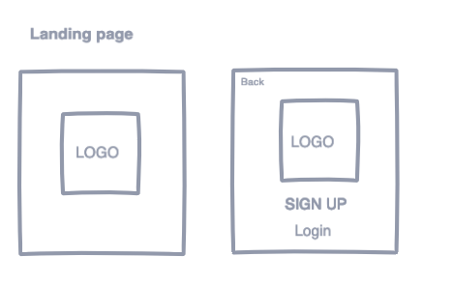

Figure 7: Landing page and login page

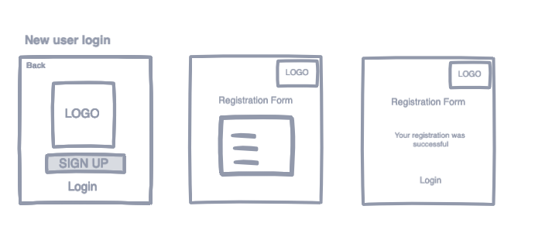

Figure 8: New user login and registration form

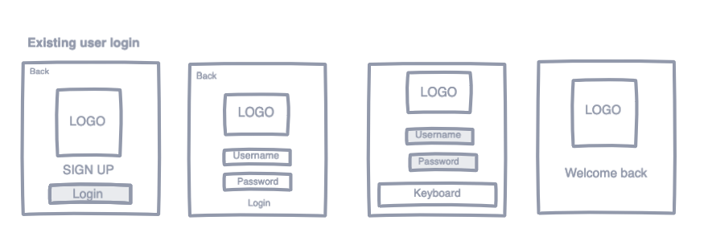

Figure 9: Existing user login pages

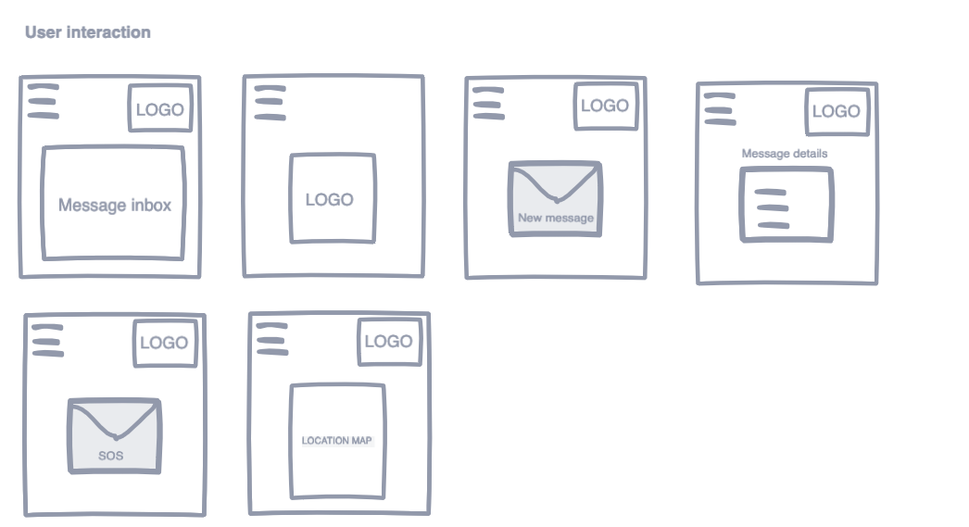

Figure 10: User interaction screens

## Branding

[*Insert colour schemes, logos etc.*]

## User Interface

## [Do some mock ups of user interface and explain]

## [System interactions]

## Prototyping

[*Insert prototyping*]

[*Write a closing paragraph to say what was discussed and what will be discussed in the next chapter*]

1. System Architecture

[*Write an introductory paragraph to state what will be discussed*]

## Functionality of system

## Systems architecture

## Technical reports

## Components

[*Write a closing paragraph to say what was discussed and what will be discussed in the next chapter*]

1. Implementation

[*Write an introductory paragraph to state what will be discussed*]

[*Write about how the system was implemented*]

## Wearable Device

[]

## App

[]

## MVP

[]

## Stage 1

[*Insert evaluation of first implementation*]

## Stage 2

[*Insert evaluation of second implementation*]

## Stage 3

[*Insert evaluation of third implementation*]

[*Write a closing paragraph to say what was discussed and what will be discussed in the next chapter*]

1. Testing

[*Write an introductory paragraph to state what will be discussed*]

## Overview of testing methods

[*Insert how the system will be tested*]

## Black box

[*What is black box testing*]

## White box

[*What is white box testing*]

## User testing

[*Insert evaluation of the device and app*]

[*Write a closing paragraph to say what was discussed and what will be discussed in the next chapter*]

1. Successes and Issues

[*Write an introductory paragraph to state what will be discussed*]

## Technical successes

## Evaluation of system

## User experience

[*Write a closing paragraph to say what was discussed and what will be discussed in the next chapter*]

1. Conclusion

# Bibliography

# Appendices

Please see below appendices to support the report.

#### 

#### [Orientation Model]

[*To be inserted*]

#### Stakeholder Focus Group Questionnaire

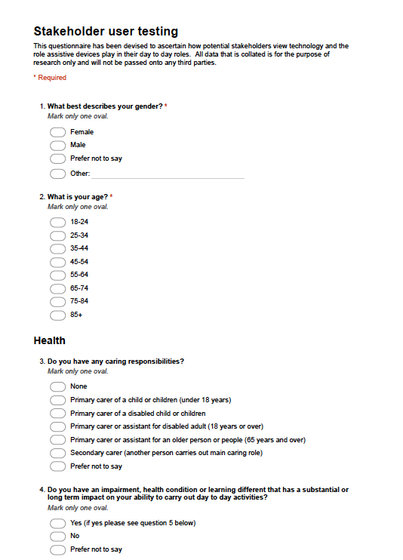

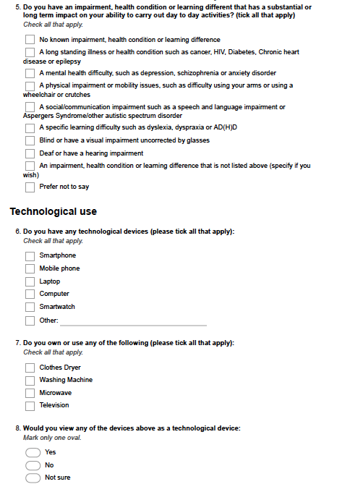

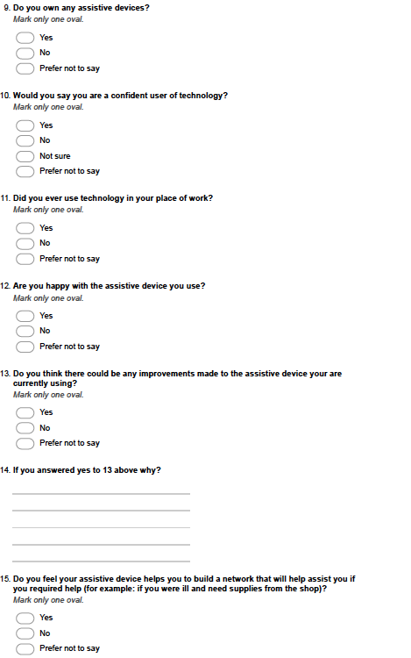

#### Conceptual Prototype Walkthrough for Stakeholder Focus Group Session

As part of the Stakeholder Focus group a conceptual prototype walkthrough was also conducted with the potential stakeholders so that they could feedback on the potential design of the system. The walkthrough was conducted by way of a PowerPoint presentation where the stakeholders were taken through step by step how the system would operate as described in Steps 1 – 8 (as shown below).

**Step 1:**

Step 1 of the conceptual prototype presented potential stakeholders with the home screen. The home screen displays two buttons: Voice control button and the SOS Button for emergency use.

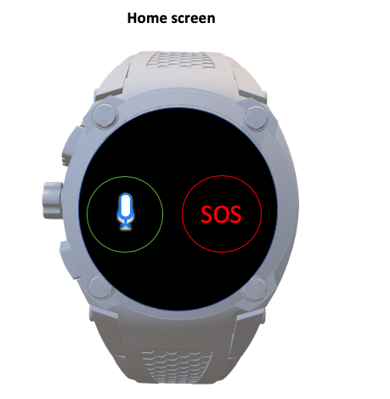

Watch casing

SOS button

Voice control button

Figure 11: Step 1 - Home Screen

**Step 2:**

Step 2 demonstrates the voice messaging screen where the user is asked to activate the voice control by pressing the green button. Voice and text feedback are given to the user to advise them that they need to keep the button pressed to record a message and release when complete.

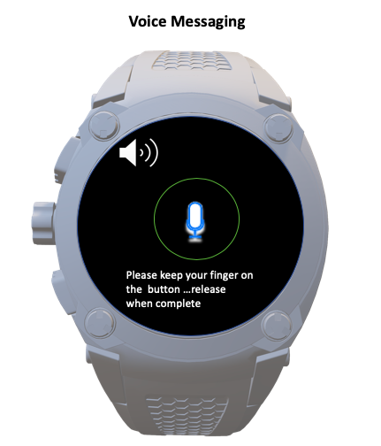

Voice feedback message

Visual feedback message

Activation of the voice control button

Figure 12:Step 2 - Voice Messaging Screen

**Step 3:**

Step 3 exhibits a voice message sent confirmation message. The feedback for the confirmation message is displayed as text on the screen and also has a voice feedback message. This is to ensure that the user understands that their voice message has been successfully sent to their NP.

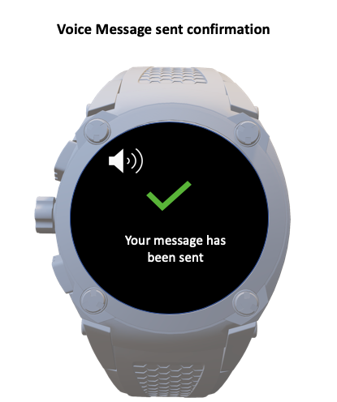

Voice feedback message

Confirmation message to notify user their message has been sent

Figure 13: Step 3 - Voice Message confirmation screen

**Step 4:**

Step 4 illustrates that once the user has successfully sent a voice message, this is then sent as a text message to the NP. A HomeHelp message icon is then displayed on the NP’s device notifying them that they have a new message from the user. The NP can then press/click on the button (according to the device they are using) to display the voice message that was sent by the user.

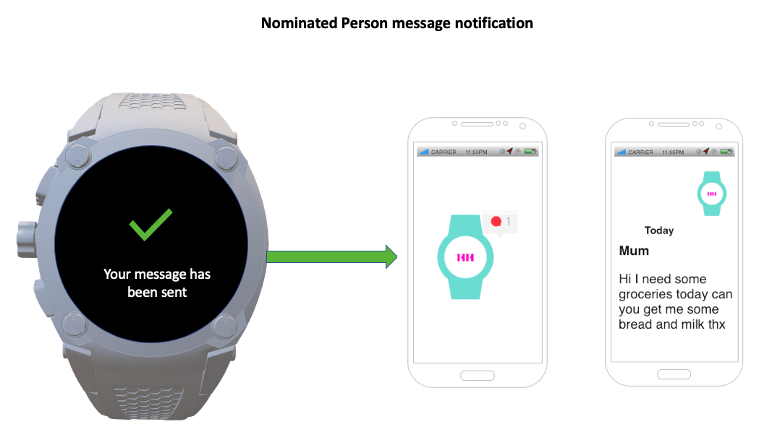

Notification message on Nominated Persons app

Message being transmitted to Nominated Person

Figure 14: Step 4 - Nominated Person message notification on the HomeHelp App

**Step 5:**

Step 5 takes the user back to the home screen once their message has been delivered to their NP.

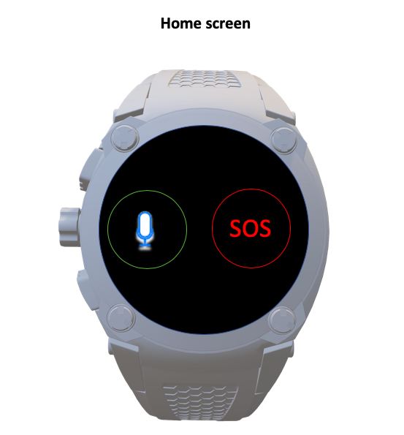

Back to the home screen once a message has been sent

Figure 15: Step 5 - Back to Home Screen

**Step 6:**

Step 6 enables the user to activate an SOS emergency alarm by pressing the red SOS button. The activation of the SOS button will alert the users NP that they need more urgent assistance.

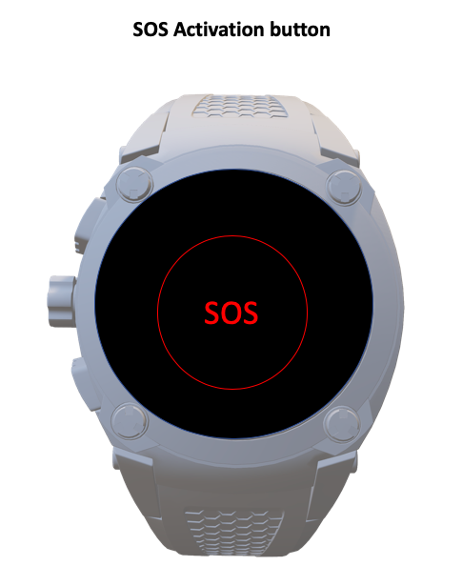

SOS Activation screen

Figure 16: Step 6 - SOS Activation Button screen

**Step 7:**

Step 7 illustrates that once the user activates the SOS button their NP will receive an SOS notification message which is displayed as a HomeHelp icon in red to highlight that it is an emergency message. When the NP presses or clicks the button (according to their device) a map will be displayed which will give the NP details of the user’s location.

An SOS symbol is displayed on a nominated persons phone

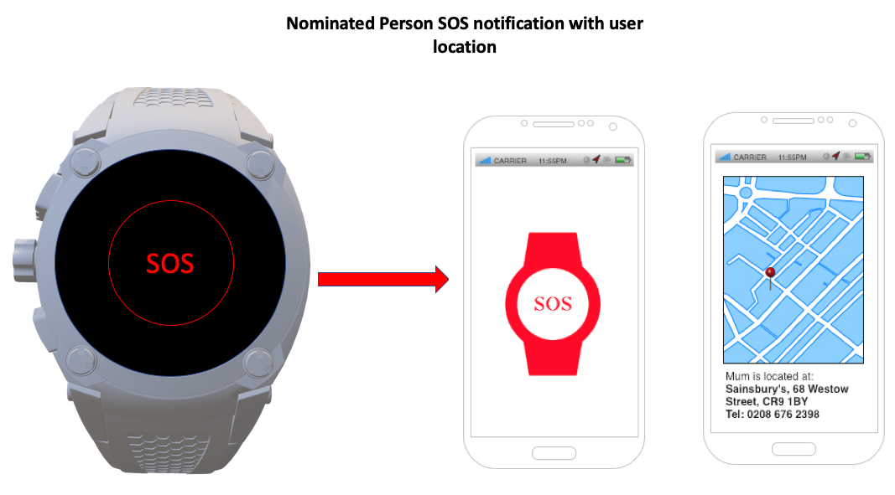

The user activates the SOS button

A map location for the user is displayed

Figure 17: Step 7 - Nominated Person SOS Notification with GPS location map of user

**Step 8:**

Step 8 introduces the potential user(s) to an alternative design for the proposed system.

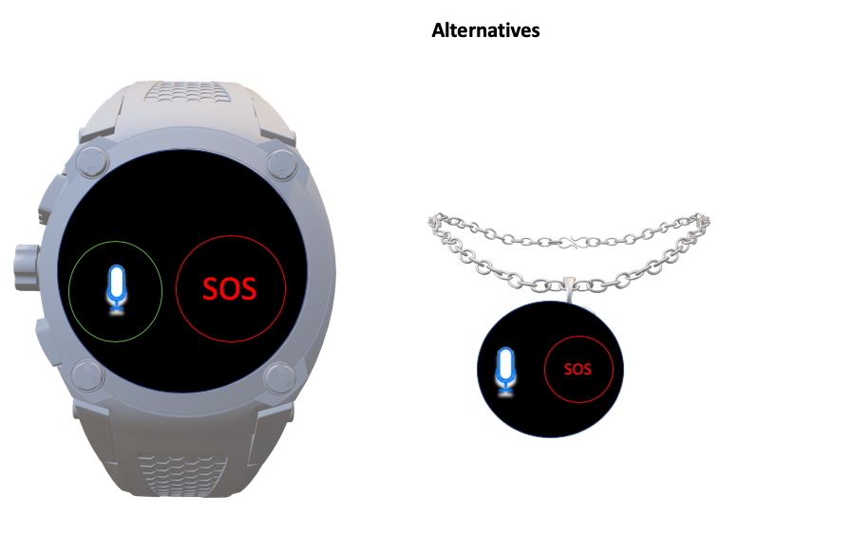

Necklace design for the proposed system

Figure 18: Step 8 - Alternative designs